Exercise 1: Logging Error Messages and Warning Levels

dependencies
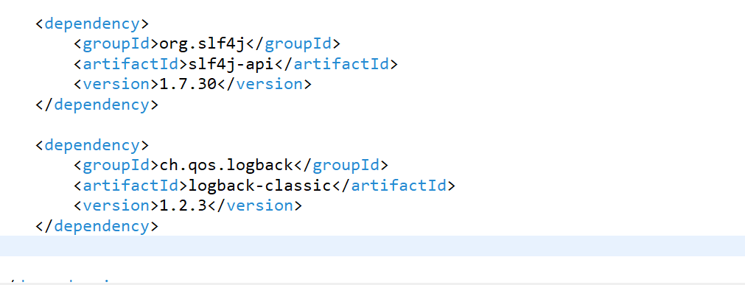
LoggingExample java class:
